**Dashboard 1 : Job and Shipment Trends**

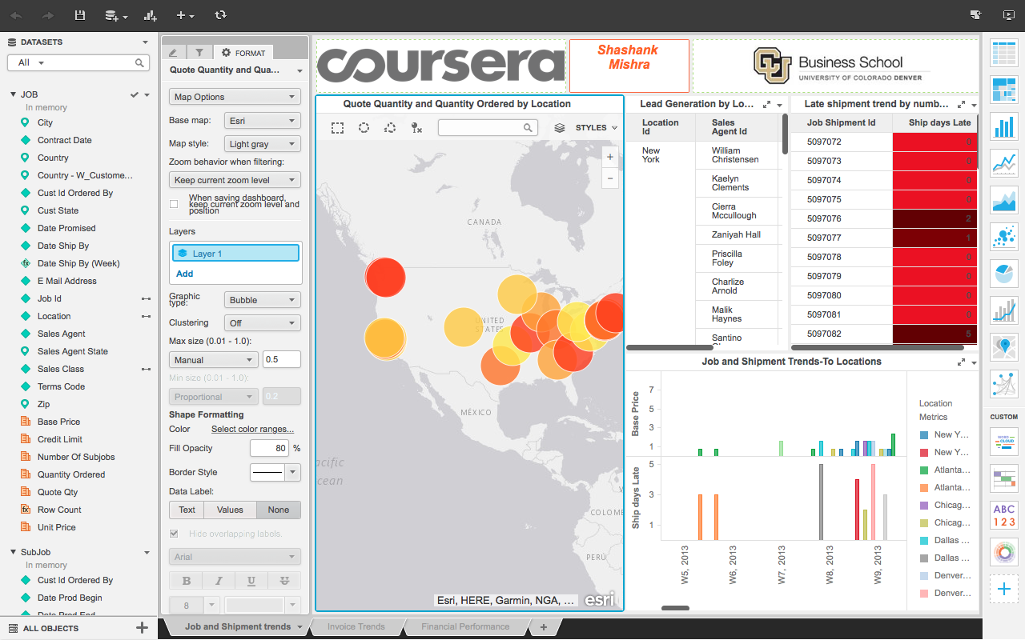

In the Quote Quantity and Quantity Ordered by Location, it is seen in the map chart about locations for zip codes. Also the information about the quantity ordered and the number of sub-jobs listed for that particular location. The bubbles in the above visualization shows the bubble chart for the areas by the quantity ordered.

In the Lead Generation by Location and Agent visualization, information about the quote price and the Quantity by Sales agent ID for cities like New York, Chicago, etc is shown. The quote quantity in red denotes the lowest quote percentage for that city.

In the Job and Shipment Trends-To-Location, bar chart shows Ship dates by week for locations on basis of their Base Price. For Shipment days late, information is displayed about the days the shipment was delayed by for a particular Job Shipment id.

**Dashboard 2 : Invoice Trends**

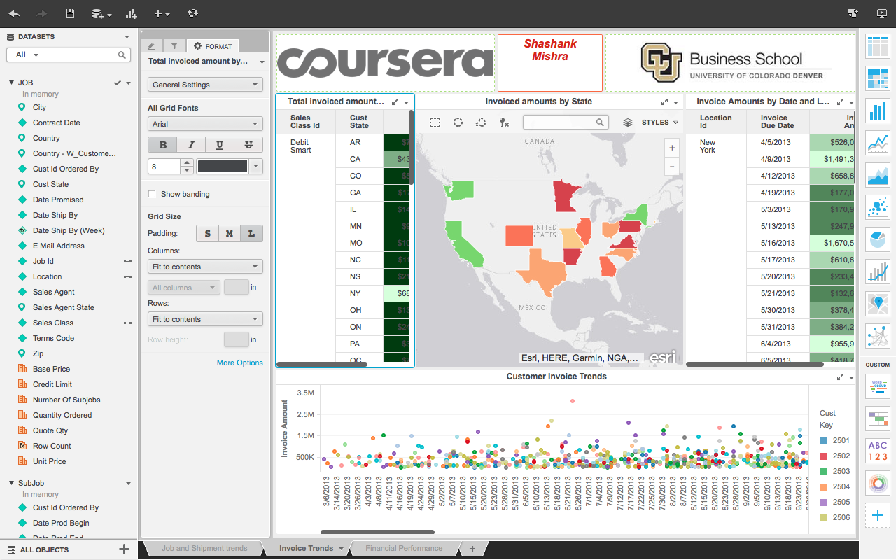

This grid data shows the Invoice amount for the Sales class Id for four different types of cards generated by CPI Inc. The invoice amount by state shows us the regions in United States by the invoice amounts. The regions showing green color have the highest invoice amount and the ones with red have the lowest invoice amount.

Customer invoice trends shows the invoice amount by the invoice due dates with respect to customer keys. It shows the Customer Invoice Amount trends by Invoice due dates and the Invoice amount which helps us understand how the Invoice amount changes over the period of time for each customer.

Invoice amounts by date and location, shows grid data information about the due dates for Invoice amount by the location id.

**Dashboard 3 : Financial Summary**

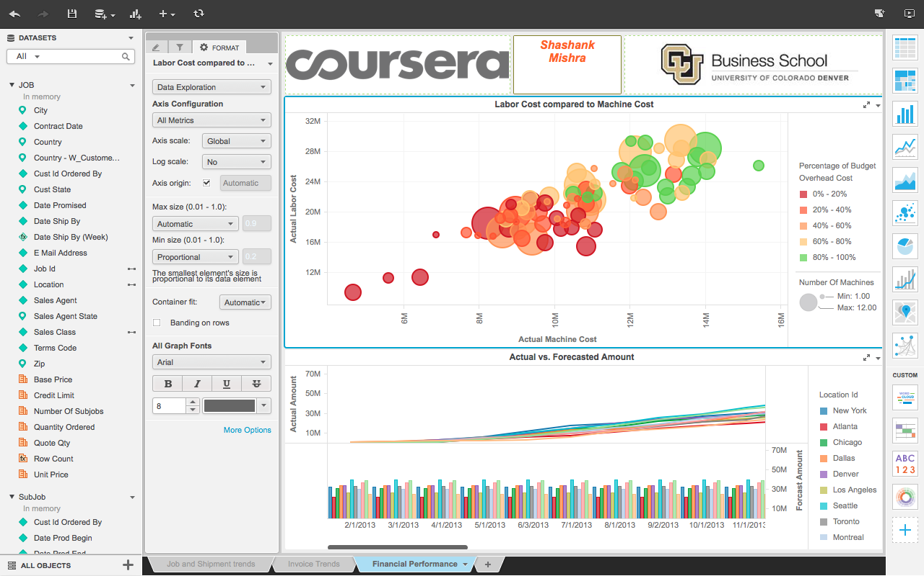

Bubble chart shows how the budget overhead cost changes to the Actual Machine Cost and Actual Labor Cost. Bubbles in red shows the lowest budget overhead cost and the ones in green show higher overhead budget cost.

**Conclusion :**

From analysis, performance indicators of the CPI Company are judged and the profit generated over the time period and analysis is carried out across particular regions. The job and shipment trends, invoice trends and the financial summary give us an overall idea about the CPI growth and also tells about the areas they need to improve upon.